Lesson 03 Demo 01

Deploying MySQL Database as Docker Container

Objective: To demonstrate how to deploy a MySQL database as a Docker container on an AWS EC2 instance with Ubuntu

Tools required: AWS Management Console

Prerequisites: An AWS EC2 instance with Ubuntu as the operating system

Steps to be followed:
- Set up an EC2 instance
- Install the Docker on Ubuntu
- Run the MySQL container
- Connect to MySQL server within container

Step 1: Set up an EC2 instance

- Launch a new EC2 instance with Ubuntu as the operating system. Ensure that you have the necessary security group rules to allow SSH access.

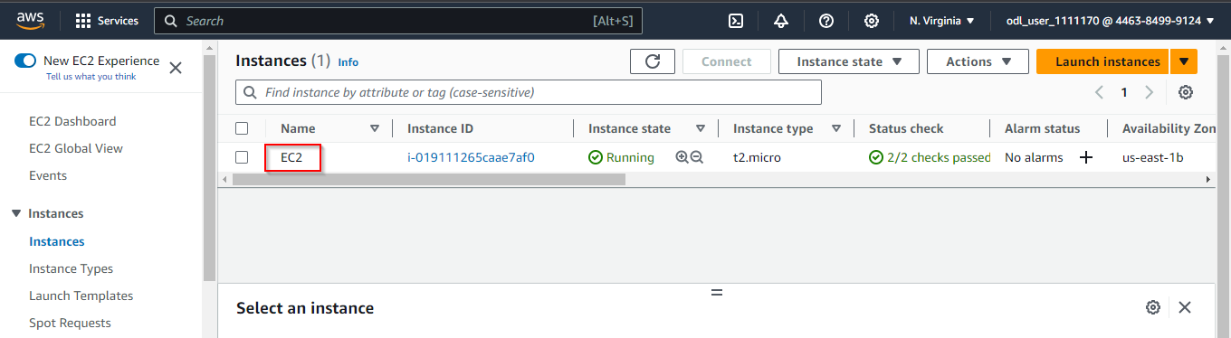

Note: Please refer to previous lesson demos on how to launch an EC2 instance.

- Select the instance and click Connect

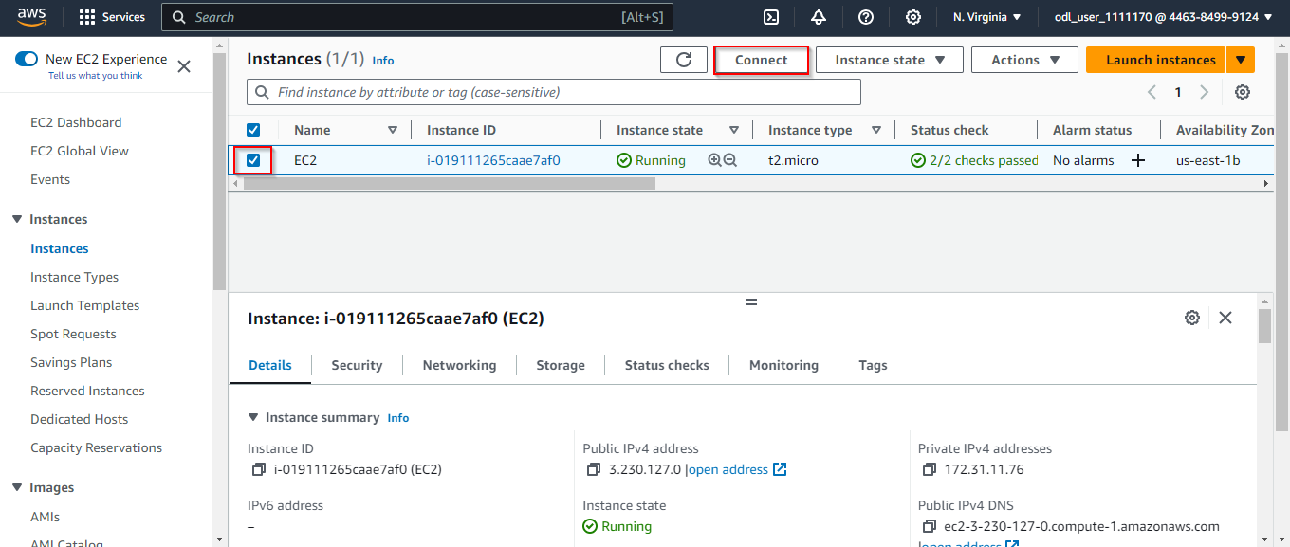

- Click Connect again to proceed

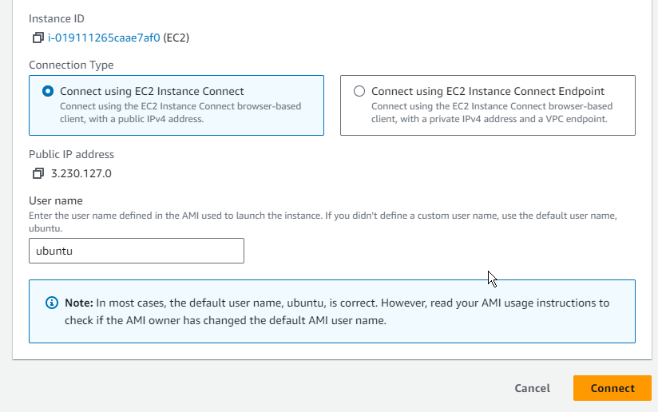

Step 2: Install the Docker on Ubuntu

- Update the package list by running the following commands:
sudo su
apt update

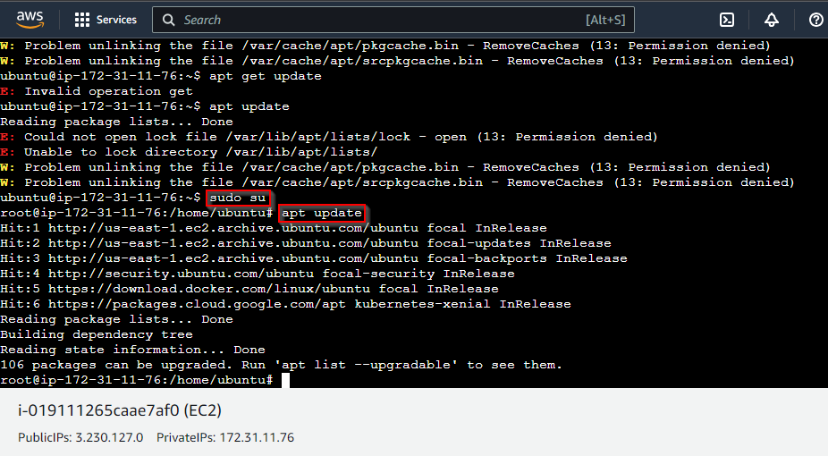

- Run the following command to install the necessary dependencies:
apt install apt-transport-https ca-certificates curl software-properties-common -y

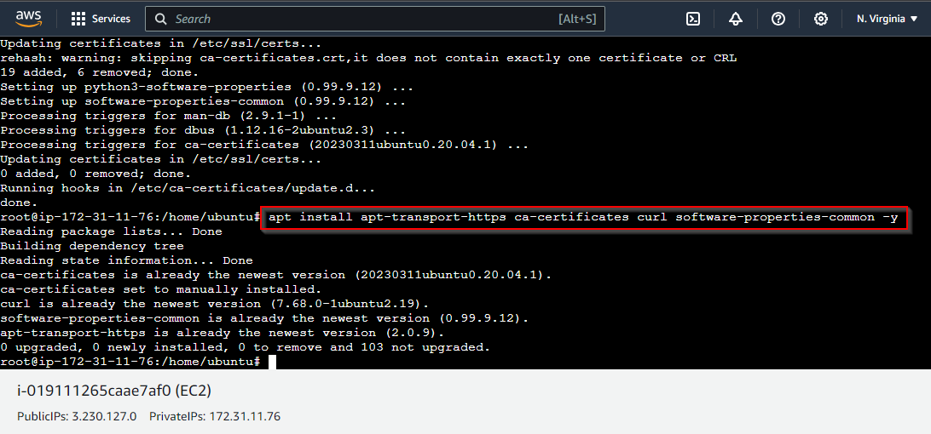

- Run the following command to add the Docker GPG key:
curl -fsSL https://download.docker.com/linux/ubuntu/gpg | sudo gpg --dearmor -o /usr/share/keyrings/docker-archive-keyring.gpg

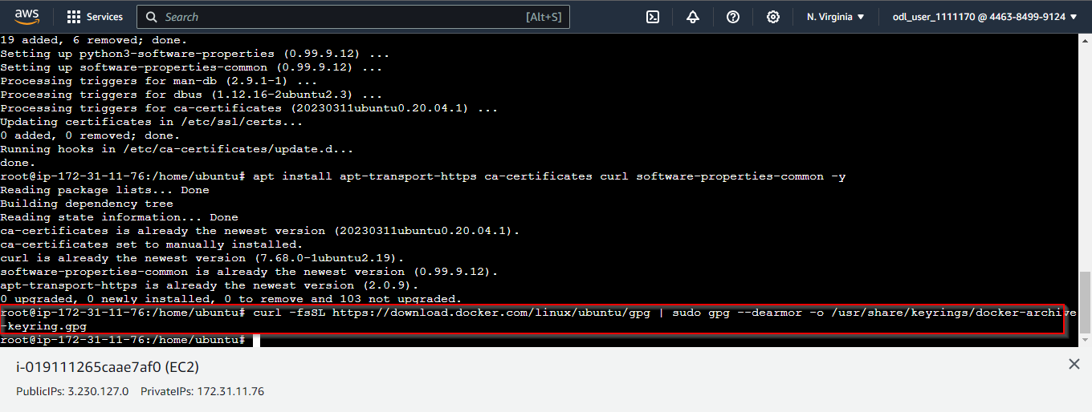

- Run the following command to add the Docker repository:
echo "deb [arch=amd64 signed-by=/usr/share/keyrings/docker-archive-keyring.gpg] https://download.docker.com/linux/ubuntu $(lsb_release -cs) stable" | sudo tee /etc/apt/sources.list.d/docker.list > /dev/null

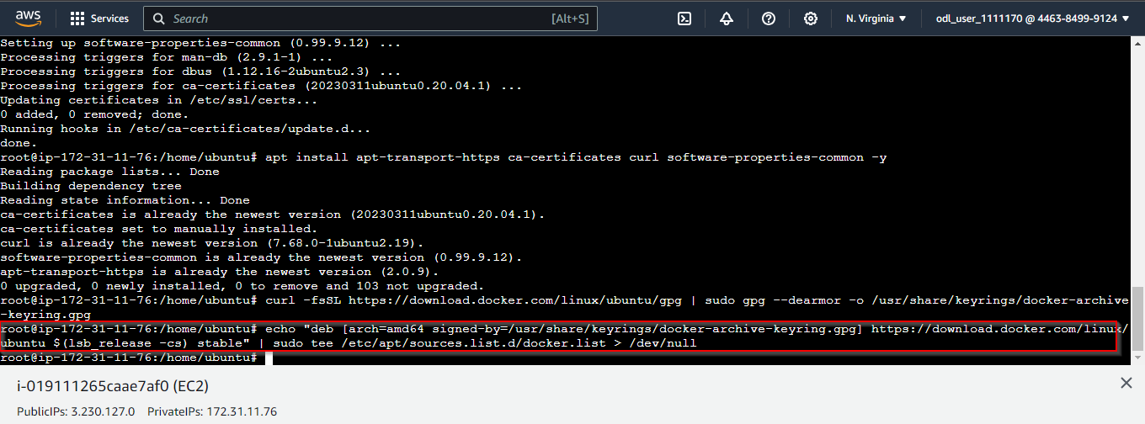

- Run the following commands to install Docker:
apt update
apt install docker-ce docker-ce-cli containerd.io

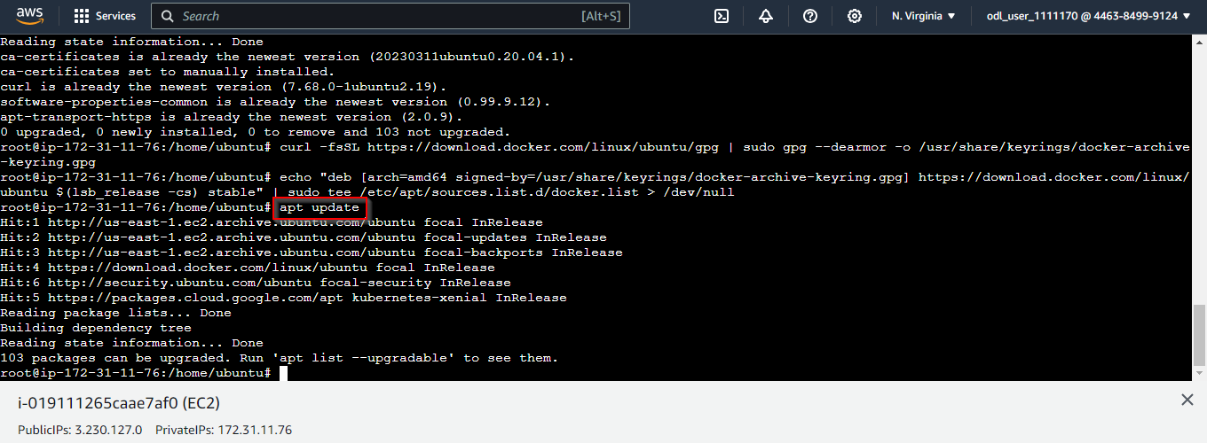
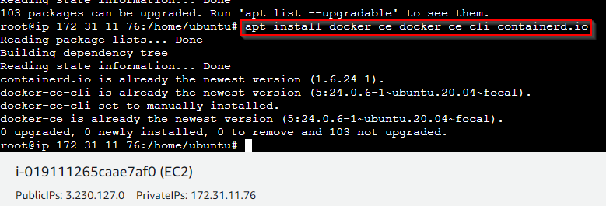

- Run the following commands to start and enable the Docker service:
systemctl start docker
systemctl enable docker

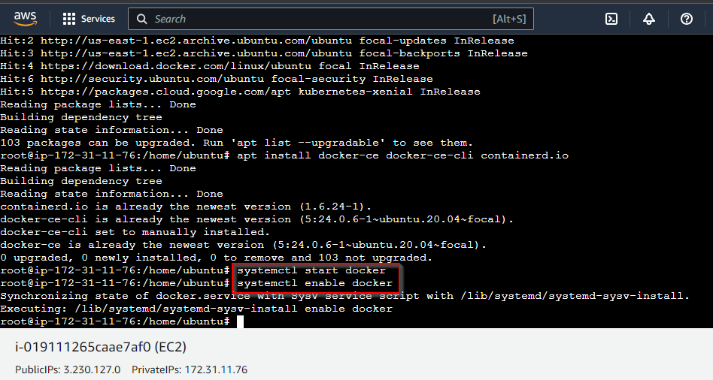

Step 3: Run the MySQL container

- Pull the latest MySQL image from Docker Hub using the following command:
docker pull mysql

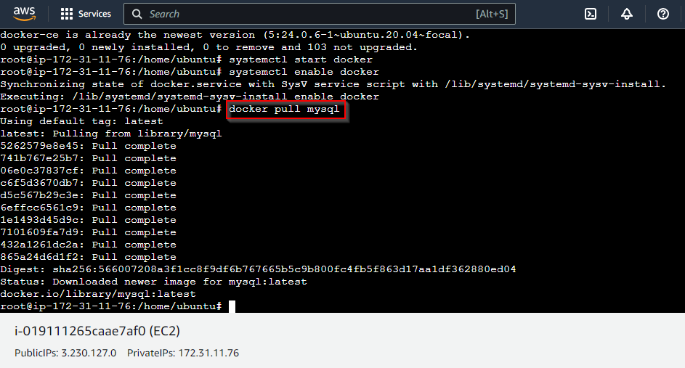

- Create a Docker volume or bind mount to store your database data persistently. For example, create a volume named mysql-data:
docker volume create mysql-data

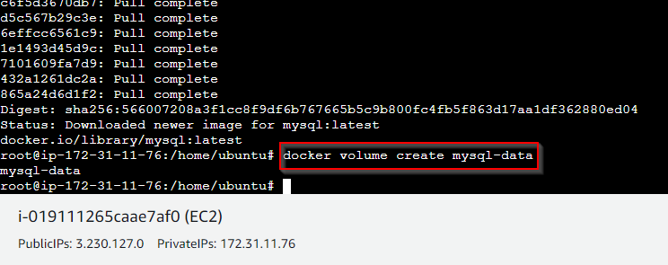

- Run a MySQL container and set a password for the root user using the MYSQL_ROOT_PASSWORD environment variable:
docker run --name my-mysql -e MYSQL_ROOT_PASSWORD=secret -v mysql-data:/var/lib/mysql -d mysql

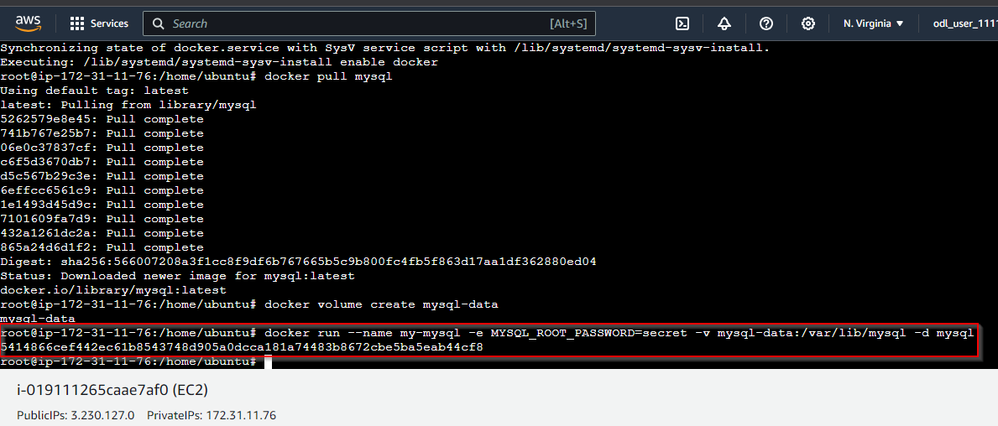

- Check the status of your container using the command:
docker ps

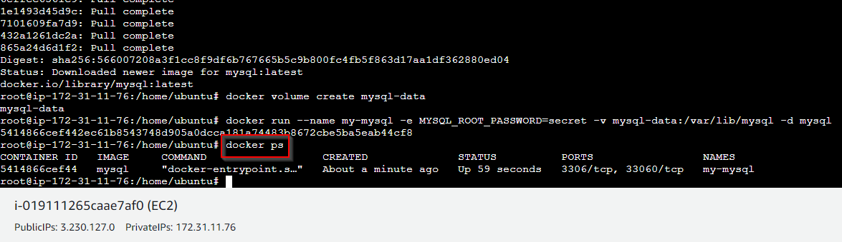

Step 4: Connect to MySQL server within container

- Connect to your MySQL server from within the container:
docker exec -it my-mysql mysql -p

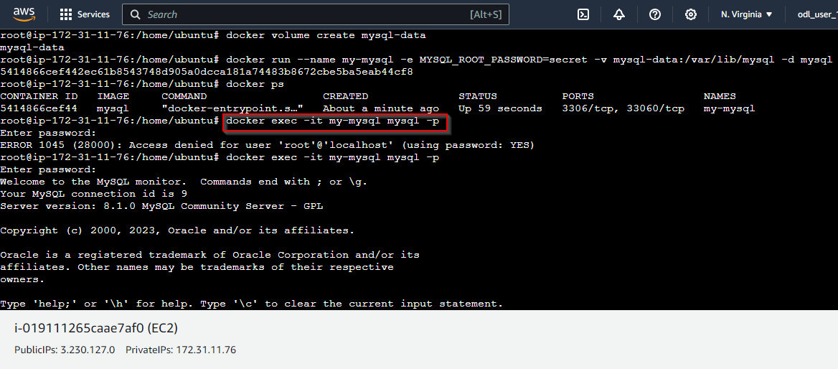

Note: Use secret as the password

- Use the MySQL command-line interface to create databases, tables, and users and to perform queries. For example, create a database named testdb:
CREATE DATABASE testdb;

use testdb;

create table emp (id integer, name text);

insert into emp values(101,"Hitesh");

select * from emp;

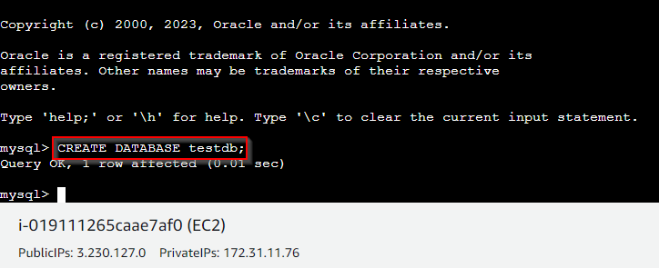

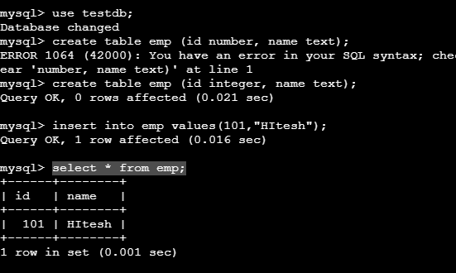

Exit the MySQL shell using the command:
exit

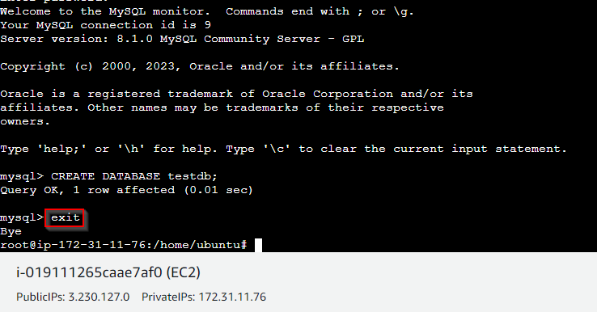

- Expose container port 3306 to host port 33060 using the following commands:
docker run --name my-mysql1 -e MYSQL_ROOT_PASSWORD=secret -v mysql-data:/var/lib/mysql -p 33060:3306 -d mysql

docker ps -a

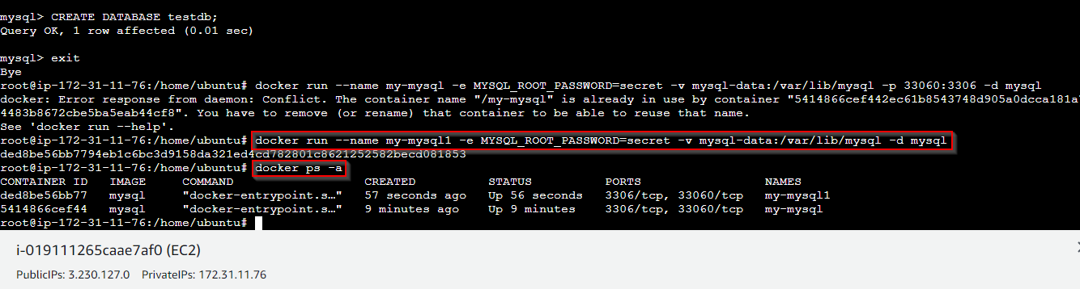

By following these steps, you have successfully deployed a MySQL database as a Docker container on your AWS EC2 instance running Ubuntu.

